Social & Economic Cost of Eating Disorders in the United States
Social Media Toolkit

- American Economy Graphic

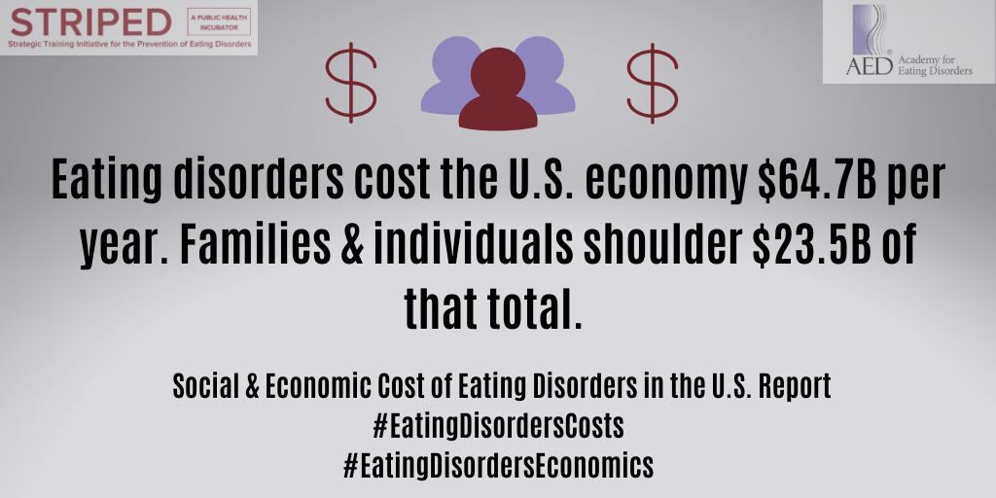

Twitter: A new report from @HarvardSTRIPED, @AEDweb & @D_AccessEcon (@Deloitte) reveals that eating disorders cost the U.S. economy $64.7B per year, with $23.5B of those costs shouldered by individuals & families. #EDawareness #EatingDisordersCosts https://bit.ly/2BlSmfA

Facebook: A new groundbreaking report from @STRIPED.Harvard, @AcademyforEatingDisorders & @DeloitteUS Access Economics reveals that eating disorders cost the American economy a whopping $64.7 billion per year, with $48.6 billion of those costs associated with productivity losses. Additionally, $23.5 billion of these costs are shouldered directly by individuals & families. #EDawareness #EatingDisordersCosts https://bit.ly/2BlSmfA

Instagram: A new groundbreaking report from @HarvardSTRIPED, @aed_iced & @Deloitte reveals that eating disorders cost the American economy a whopping $64.7 billion per year, with $48.6 billion of those costs associated with productivity losses. Additionally, $23.5 billion of these costs are shouldered directly by individuals & families. #EDawareness #EatingDisordersCosts https://bit.ly/2BlSmfA

- POC Graphic

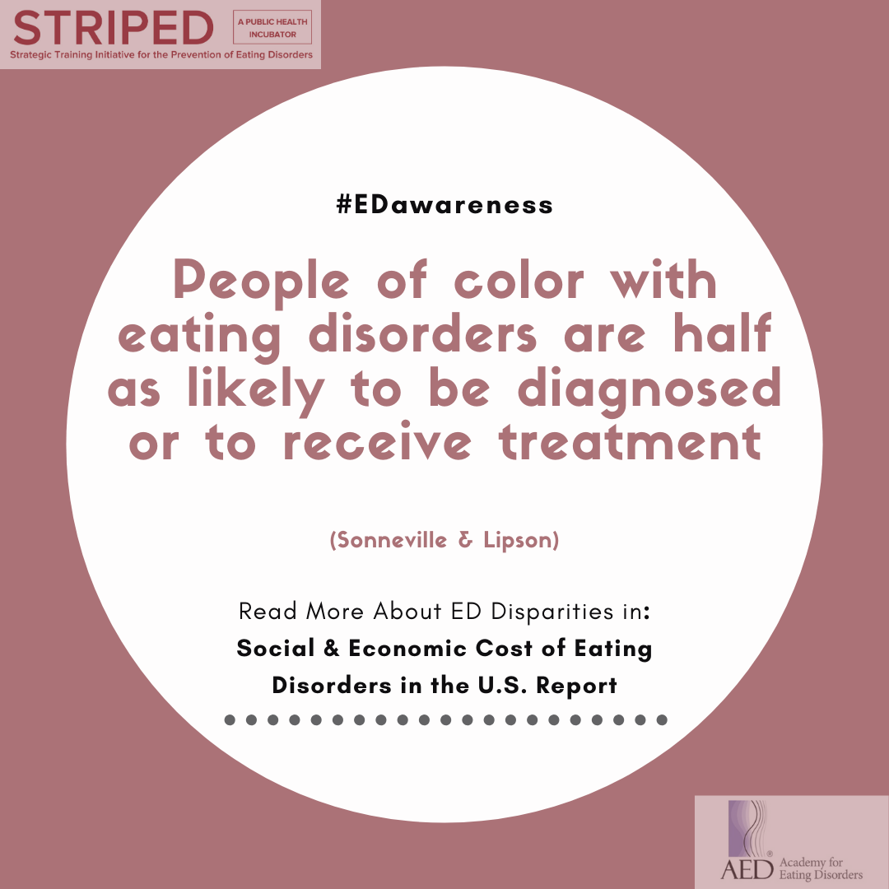

Twitter: DYK POC with EDs are half as likely to be diagnosed or to receive treatment? Learn more about other disparities associated with EDs in a new report from @HarvardSTRIPED, @AEDweb & @D_AccessEcon (@Deloitte): https://bit.ly/2BlSmfA #BLM #EatingDisorders

Facebook: Did you know that people of color with eating disorders are half as likely to be diagnosed or to receive treatment? Learn more about other disparities associated with eating disorders in a new report from @STRIPED.Harvard, @AcademyforEatingDisorders & @DeloitteUS Access Economics: https://bit.ly/2BlSmfA #BLM #EatingDisorders

Instagram: Did you know that people of color with eating disorders are half as likely to be diagnosed or to receive treatment? Learn more about other disparities associated with eating disorders in a new report from @HarvardSTRIPED, @aed_iced & @Deloitte: https://bit.ly/2BlSmfA #BLM #EatingDisorders

- 6 Weeks Graphic

Animation (click the link to access and download graphic)

Twitter: DYK individuals & families provide 6 weeks of informal, unpaid care per year to support loved ones with eating disorders? Learn more within the @HarvardSTRIPED, @AEDweb & @D_AccessEcon (@Deloitte) report here: https://bit.ly/2BlSmfA

Facebook: Explore the new report from @STRIPED.Harvard, @AcademyforEatingDisorders & @DeloitteUS Access Economics, which finds individuals & families provide up to 6 weeks of informal and unpaid care every year to support loved ones affected by eating disorders: https://bit.ly/2BlSmfA

Instagram: Explore the new report from @HarvardSTRIPED, @aed_iced & @Deloitte, which finds individuals & families provide up to 6 weeks of informal and unpaid care every year to support loved ones affected by eating disorders: https://bit.ly/2BlSmfA

- ER Visits Graphic

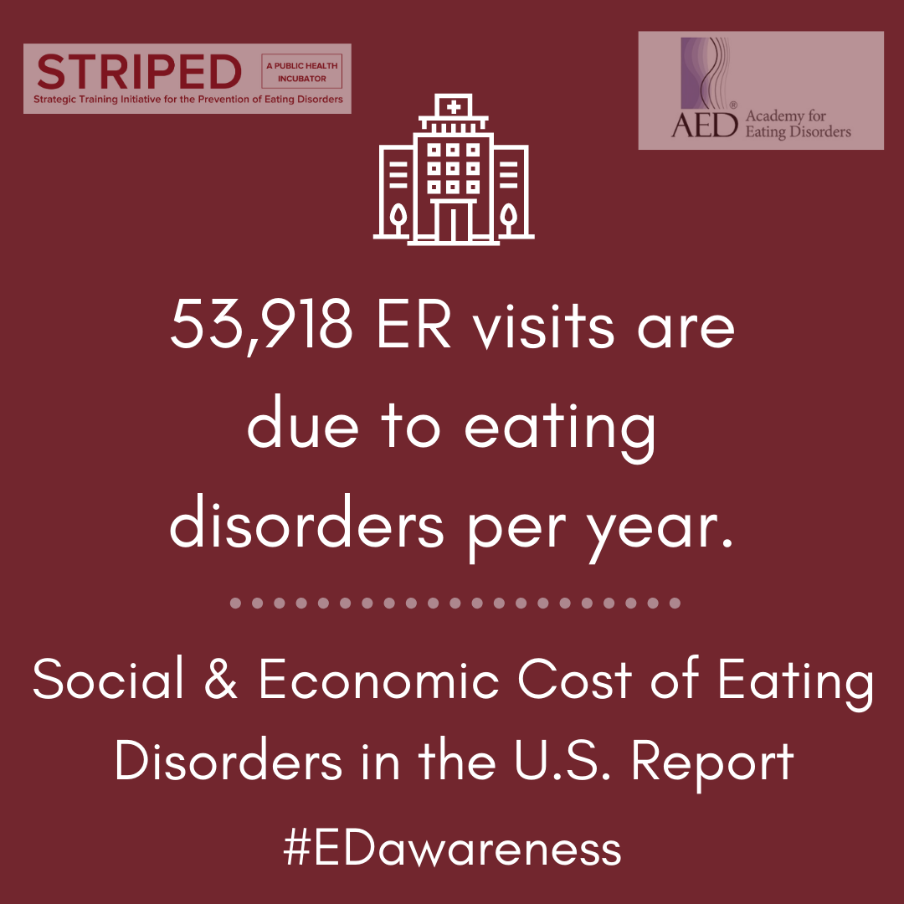

Twitter: A new report from @HarvardSTRIPED, @AEDweb & @D_AccessEcon (@Deloitte) found that 53,918 ER visits were directly related to eating disorders in 2019. #EDawareness #EatingDisordersCosts. https://bit.ly/2BlSmfA

Facebook: In a new report from @STRIPED.Harvard, @AcademyforEatingDisorders & @DeloitteUS Access Economics, 53,918 visits to the emergency room in 2019 were directly related to health conditions linked to an eating disorder. You can read more here: https://bit.ly/2BlSmfA. #EDawareness #EatingDisordersCosts

Instagram: In a new report from @HarvardSTRIPED, @aed_iced & @Deloitte, 53,918 visits to the emergency room in 2019 were directly related to health conditions linked to an eating disorder. You can read more here: https://bit.ly/2BlSmfA. #EDawareness #EatingDisordersCosts

- 9% Graphic

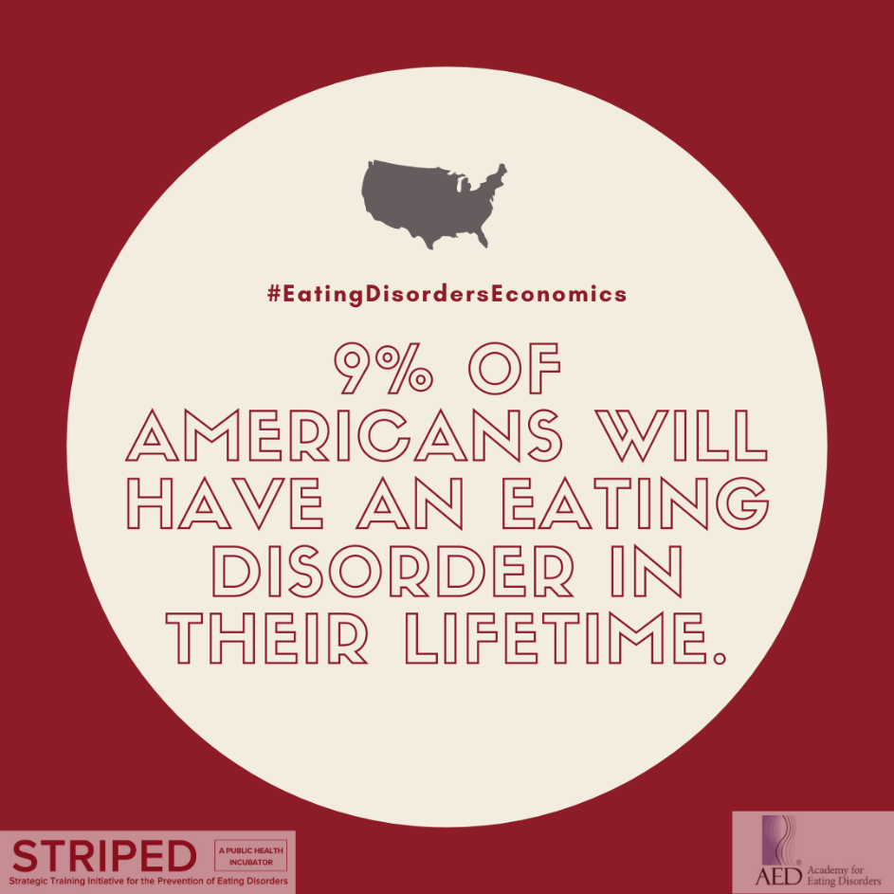

Twitter: Did you know that 9% of the U.S. population, or 28.8M Americans, will have an eating disorder during their lifetime? Read more from a new @HarvardSTRIPED, @AEDweb, @D_AccessEcon (@Deloitte) report. #EDawareness. https://bit.ly/2BlSmfA
Facebook: Did you know that 9% of the U.S. population, or 28.8 million Americans, will have an eating disorder at some point during their lifetime? Read more in a new report from @STRIPED.Harvard, @AcademyforEatingDisorders & @DeloitteUS Access Economics. #EDawareness. https://bit.ly/2BlSmfA
Instagram: Did you know that 9% of the U.S. population, or 28.8 million Americans, will have an eating disorder at some point during their lifetime? Read more in a new report from @HarvardSTRIPED, @aed_iced & @Deloitte. #EDawareness. https://bit.ly/2BlSmfA

- 10,200 Graphic

Animation (click the link to access and download graphic)

Twitter: DYK that 10,200 deaths per year in the U.S., or 1 death every 52 minutes, are a direct result of an eating disorder? Learn more about this #mentalillness in a new report by @HarvardSTRIPED, @AEDweb & @D_AccessEcon (@Deloitte): https://bit.ly/2BlSmfA

Facebook: Did you know that roughly 10,200 deaths per year in the U.S. are a direct result of an eating disorder? This equates to an astounding 1 death every 52 minutes from an eating disorder. Learn more about this #mentalillness in a new report by @STRIPED.Harvard, @AcademyforEatingDisorders & @DeloitteUS Access Economics: https://bit.ly/2BlSmfA

Instagram: Did you know that roughly 10,200 deaths per year in the U.S. are a direct result of an eating disorder? This equates to an astounding 1 death every 52 minutes from an eating disorder. Learn more about this #mentalillness in a new report by @HarvardSTRIPED, @aed_iced & @Deloitte: https://bit.ly/2BlSmfA

- Gender Graphic

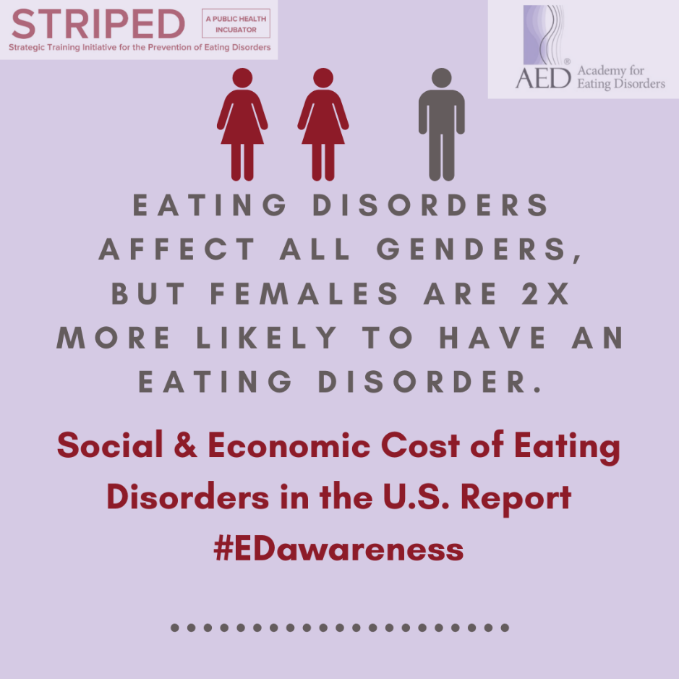

Twitter: A new report from @HarvardSTRIPED, @AEDweb & @D_AccessEcon (@Deloitte) shows that eating disorders affect all genders of all ages, but women are 2x more likely to be affected by an eating disorder. #EDawareness https://bit.ly/2BlSmfA
Facebook: A new report from @STRIPED.Harvard, @AcademyforEatingDisorders & @DeloitteUS Access Economics shows that eating disorders affect all genders of all ages, starting as young as 5 or as old as 80, but women are 2x more likely to be affected by an eating disorder. #EDawareness. https://bit.ly/2BlSmfA
Instagram: A new report from @HarvardSTRIPED, @aed_iced & @Deloitte shows that eating disorders affect all genders of all ages, starting as young as 5 or as old as 80, but women are 2x more likely to be affected by an eating disorder. #EDawareness https://bit.ly/2BlSmfA

- 5% increase Graphic

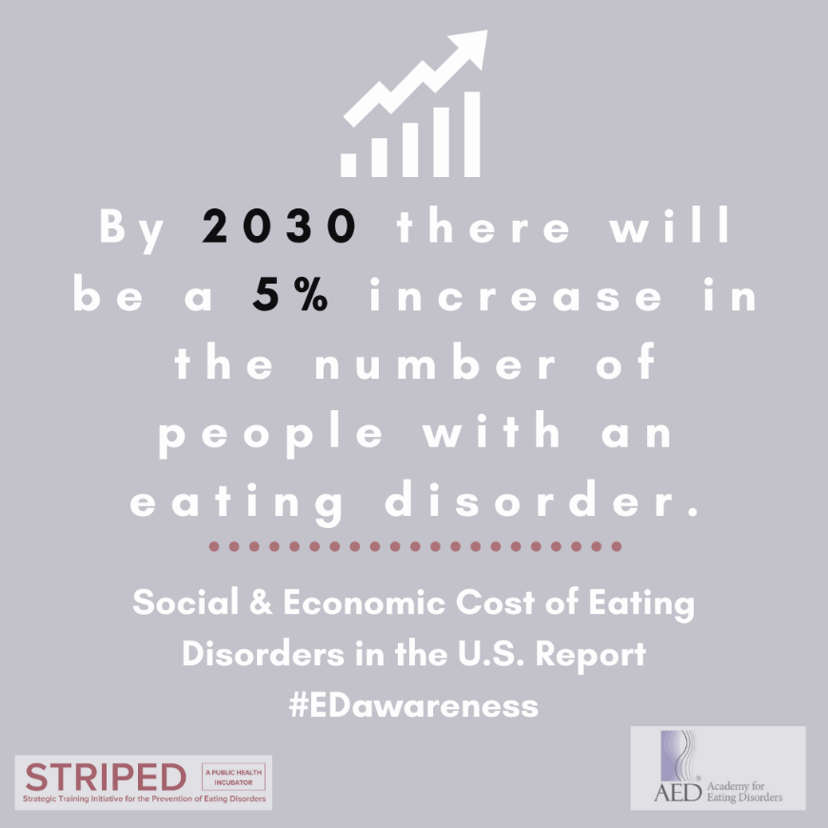

Twitter: A report just published by @HarvardSTRIPED, @AEDweb & @D_AccessEcon (@Deloitte) estimates that the number of Americans affected by an eating disorder will increase 5% by 2030: https://bit.ly/2BlSmfA #EDawareness
Facebook: A report recently published by @STRIPED.Harvard, @AcademyforEatingDisorders & @DeloitteUS Access Economics estimates that the number of Americans affected by an eating disorder will increase 5% by 2030: https://bit.ly/2BlSmfA #EDawareness
Instagram: A report just published by @HarvardSTRIPED, @aed_iced & @Deloitte estimates that the number of Americans affected by an eating disorder will increase 5% by 2030: https://bit.ly/2BlSmfA #EDawareness

Save the Date Graphics
Save the Date Animation (click the link to access and download graphic)
AND
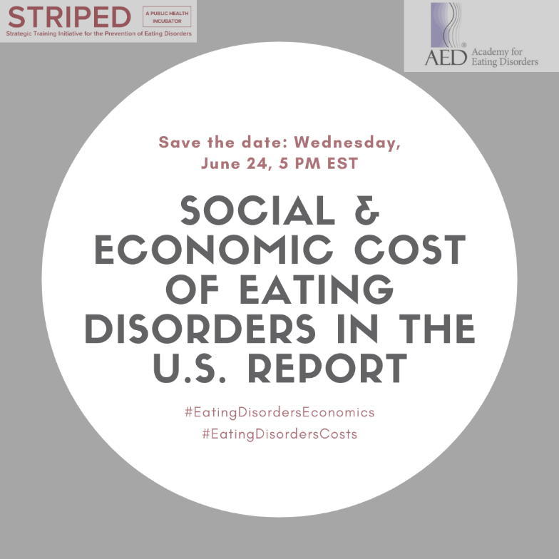
Twitter-Specific Save the Date
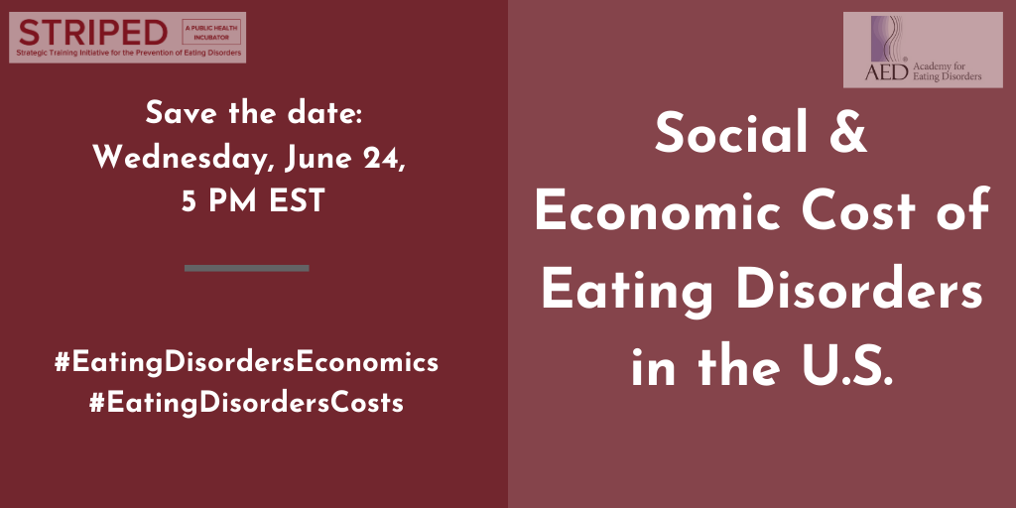
Twitter: @HarvardSTRIPED, @AEDweb & @D_AccessEcon (@Deloitte) are publishing the first-ever report on the economic cost of #eatingdisorders in the #US on June 24 at 5 PM ET. Click https://bit.ly/2BlSmfA to watch the report launch live. #EDawareness

Facebook: ICYMI, @STRIPED.Harvard, @AcademyforEatingDisorders & @DeloitteUS Access Economics are publishing the first-ever report on the total economic and social costs associated with #eatingdisorders in the United States on June 24 at 5 PM ET. Use the following link: https://bit.ly/2BlSmfA to access the livestream of the report launch. #EDawareness

Instagram: ICYMI, @HarvardSTRIPED, @aed_iced & @Deloitte are publishing the first-ever report on the total economic and social costs associated with #eatingdisorders in the United States on June 24 at 5 PM ET. Use the following link: https://bit.ly/2BlSmfA to access the livestream of the report launch. #EDawareness
Standalone Social Media Sample Messages
- Twitter: @HarvardSTRIPED, @AEDweb & @D_AccessEcon (@Deloitte) have produced the first-ever report on the economic costs of eating disorders, and the results are astonishing. Read the report here: https://bit.ly/2BlSmfA #EatingDisordersEconomics

Facebook: @STRIPED.Harvard, @AcademyforEatingDisorders & @DeloitteUS Access Economics through rigorous research have compiled the first-ever report on the economic and social costs of eating disorders in the United States, and the results are astonishing. Read the report here: https://bit.ly/2BlSmfA #EatingDisordersEconomics

Instagram: @HarvardSTRIPED, @aed_iced & @Deloitte through rigorous research have compiled the first-ever report on the economic and social costs of eating disorders in the United States, and the results are astonishing. Read the report here: https://bit.ly/2BlSmfA #EatingDisordersEconomics

- Twitter: #COVID19 has made it difficult to seek eating disorders treatment, exacerbating health disparities. POC were already half as likely to be diagnosed or to receive treatment. Read more about these issues in a report by @HarvardSTRIPED, @AEDweb & @D_AccessEcon (@Deloitte).

Facebook: #COVID19 has made it difficult to seek treatment for eating disorders, exacerbating health disparities. People of color were already half as likely to be diagnosed or to receive treatment. Read more about the consequences of health disparities & forgoing care for eating disorders in a report by @STRIPED.Harvard, @AcademyforEatingDisorders & @DeloitteUS Access Economics.

Instagram: #COVID19 has made it difficult to seek treatment for eating disorders, exacerbating health disparities. People of color were already half as likely to be diagnosed or to receive treatment. Read more about the consequences of health disparities & forgoing care for eating disorders in a report by @HarvardSTRIPED, @aed_iced & @Deloitte.

